Ethical dilemma question:
Is it fair to set a high price on essential drugs in the USA, where many people unaffordable to use them?

Student number: C012345

Word count: 3000

Content Table

- Introduction Page 3
- Consumers and medical prices Page 3
- Companies Page 5
- Conclusion Page 6
- Bibliography Page 7

Introduction
In the past decade, the cost of medications and treatments for several illnesses in the United States have become more and more expensive. Healthcare costs have increased substantially, particularly on prescription drugs and hospitalization. The historical increase in drug spending and prices is contributing to the extreme cost of health care in the United States makes it is the most expensive healthcare system of any country in the world with Health consumption expenditures per capita is $10,966 US dollars a year in comparison to the second and third countries are Switzerland and Germany with $7,732 and $6,646 (How Does Health Spending in the U.S. Compare to Other Countries?, 2021). "As out-of-pocket costs for prescription medications have risen steadily, at a rate faster than inflation, many people are personally experiencing the hardship of rising costs.

In the United States, the pharmaceutical industry is a private sector industry, which is referred to as pharmaceutical companies. These companies are for-profit commercial ventures licensed to conduct medical research, develop drugs for the marketplace, market and distribute medicines. As a private sector, one of their primary purposes is to make the money and try to maximize profit. If this drug were a typical good and not an essential one, the pharmaceutical company would have to set its price at an equilibrium level to benefit both customers and companies. However, life-saving drugs have extremely inelastic demand. No matter what the price, buyers will still pay for the drugs unless they don’t want to live. Takes advantage of this exclusive market they use the high demand and set the price at whatever they are "comfortable" with. So who's at fault? The patients or the companies? We can blame and excuse the pharmaceutical industry but though the whole system is the fault, the greedy individuals and the pharmaceutical industry are only part of the problem.

The consumers and medical price

In the pharmaceutical industry, most of the companies have taken advantage of its exclusivity of the market conditions by charging significantly more for drugs than the patients are willing to pay. For most of the cases, the ones who are in the middle and lower class are the vulnerable patients. They are the victims of these unwanted expenditures. Companies offer their consumers the choice of paying to live or stopping living, and of course nobody wants to pick the second option. If they are planning to recover and save the lives, they must be able to pay the increased costs of prescription drugs that are out-of-pocket. According to a research carried out by Gallup and West Health over the past 5 years, there is a number of more than 13% of American population, who are over 18 years old, have at least one friend or family member who died because of not receiving essential medications. The reason that leads to this situation because they were not affordable to those overpriced treatments (Cha, Ariana Eunjung. 2019). Drug prices have prevented nearly one in 10 American adults from taking their medications as prescribed, according to the Centers for Disease Control and Prevention's National Center for Health Statistics." Patricia Maryland, DrPH, president of healthcare operations and COO for St. Louis-based Ascension, shared her thoughts on the dangers of high drug costs for The Hill (Mackenzie B. ,2017)

This was a prevalent issue in the media recently when the CEO of a major pharmaceutical company increased the price of Daraprim, a life-saving HIV/AIDS and auto-immune disorder medication, by 4,000 percent overnight. This increased the price of these pills to 750 dollars each, far out of the financial reach of many to whom they are a necessity. (Ariana, E.C. 2015) The market conditions that have allowed for such a substantial price hike are affected by government intervention, but further intervention or a return to a free-market approach for pharmaceuticals could prevent the makers of drugs from having price control. Because the pharmaceutical market is complex and diverse, it will be challenging to rein in costs while still encouraging drug innovation. But it is certainly possible. There are many practical policies that could significantly curtail prices while incentivizing robust research and development. These problems, along with their specific drivers, are creating barriers to health care access that affect patients, providers, and payers. I also identify a broad range of possible policy actions that would curb high drug prices.

In the last year 2019, the Vermont senator Bernie Sanders posted on Twitter reminded his experience 20 years ago when in 1999, he took a working-class lady, struggling with breast cancer to Canada to buy the same medication for 1/10th of the price she was paying in the US.

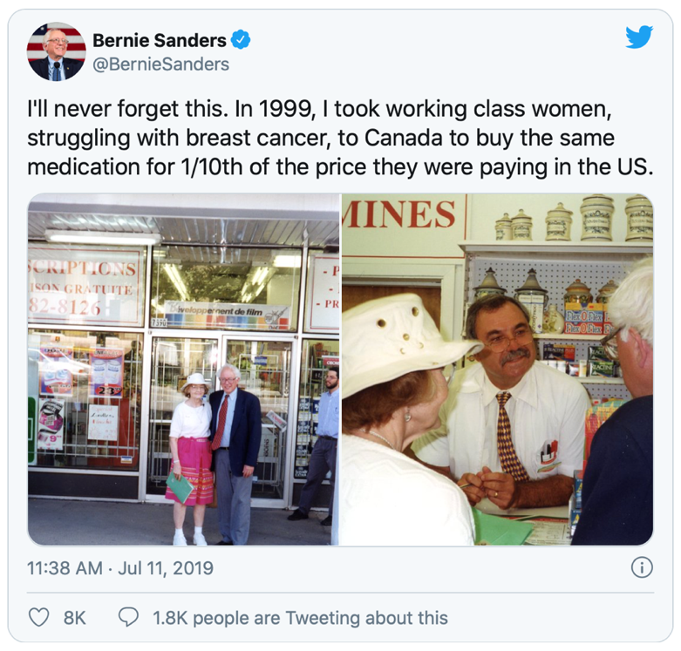

Few days later, he announced his planned trip that would accompany a group of diabetics to Canada to buy insulin with the caption “We can't wait for drug companies to lower prices. Americans need relief now!” (Jake, J. (2019). The reason for this is a vial of insulin needed by type 1 diabetics to regulate blood sugar usually costs $340 USD, about 10 times more than Canada which costs only $45 Canada dollars or $35 in the US dollars for the same insulin from the same company. Mr. Sanders and the diabetic team made the trip in order to raise awareness of the American difficulty with medicine company.

Also, in the end of 2019, a group of type 1 diabetics from Minnesota went to London, Ontario to buy insulin. "A quarter of Americans have to stop using insulin or limit it because they cannot afford it, so many people are dying" Quinn Nystrom, 33, one of the organizers that lead the group, said insulin prices in the US have skyrocketed over the past two decades (Katrina. P. (2019). Generally, there are more than 30 million Americans have diabetes, of which about 7.5 million people need insulin, according to the American Diabetes Association (ADA), more than 1.5 million people have type 1 diabetes. However, the average price of this drug has increased nearly tripled between 2002 and 2013, according to last year's ADA’s report. This sparked a lot of controversies about the United States' healthcare system admit there are 52% of Americans are members of the working or 29% lower classes whose average income of each household is under $48.000 per year so pay $340 dollars for a vial of insulin is unacceptable. (Jessie. B. ,2020)

The companies

On the other hand, an important factor that significantly increases the cost of those disease medications is the total expenditure that a pharmaceutical company has to invest in researching and developing processes of several innovative treatments. In addition to that, this expense also consists of the cost of failed experiments in which those drugs were tested on humans but showed an unsuccessful result. They did not either meet the requirements for safety conditions or satisfy the appropriate dosages. The major reason that makes these errors costly is because those companies have lost roughly about 95% of these trials. This means that only a tiny rate of 5% of medicines produced are qualified to be ready for the market. Even though there is an increasing number of pharmaceutical companies that are engaging in research and development, no breakthrough has occurred. They have an ambition to create the treatment remaining the same quality but at a lower price their predecessors. However, the market is still waiting for a pioneering, promising product that can have a great impact on the standard price of the American medication market. According to a research, on an average of about twenty medication trials for new treatment, only one product is qualified to enter the test phase. (Johnson, 2019). Similarly, other pharmaceutical companies in the United States have to give up on the majority of their trials in the development process.

Currently, Forbes has carried out research on the expenditure that pharmaceutical companies have to invest. A staggering statistic was released. It shows that $350 million is the average investment that a company should prepare if it is ambitious to innovate a brand-new medication and making it available on the market. Furthermore, many companies do not focus on developing just a single drug project. Sometimes, these companies are able to innovate numerous medications at the same time, entailing the number of total investments could be up to a billion dollars (Matthew. H. ,2013). These companies are the giants in this industry who can handle several failed trials while maintaining their stability. To illustrate this, the table below provides a brief overview of those pharmaceutical companies that spend the most massive amount of money investing in research and development phases for their products. Especially, the global healthcare company Abbott ranked first among those places to be the one that invests the most in pharmaceutical laboratories with an amount of over $13 billion. Most importantly, that money was spent in a period of over 10 years just for developing only one new medication treatment.

 | Company | Number of new drugs | 10-year R&D spending ($Mil) | R&D per drug ($Mil)
1 | Abbott | 1 | 13183 | 13183
2 | Sanofi | 6 | 60768 | 10128
3 | AstraZeneca | 4 | 38245 | 9561
4 | Hoffmann-La Roche | 8 | 70928 | 8866
5 | Pfizer | 10 | 77786 | 7779

Additionally, the policies system that are applied on the US pharmaceutical market have a profound impact on those companies and their own Research and Development (R&D) efforts. It is normally a considerable long time, and in some cases even years, prior to a company being permitted to carry out its new development, for the American authoritative agencies to permit and approve their new products. This means that it is the only owner on the market registered for the official patent. However, the wait time is extremely long: it can take up to twenty four months for a general drug to be approved by the Food and Drug Administration (FDA) and entering the market. A diamond would be more valuable because of the path of transporting it to the buyers is perilous but a coal is not. At some aspects, medicine is same.

Conclusion
“A failed health care system is when a doctor fails to treat an illness that is treatable.” - Kevin Alan Lee. A fact that is true for this situation when lots of people cannot afford essential medicines that support their lives. In conclusion, we all agree and respect the scientists and pharmaceutical hard-working aim to provide the patient life-saving treatments and breakthrough cures. If new drugs do not compensate and bring profits to companies, these companies will not be interested in researching new drugs anymore. Then, we will be the one who suffer the most. However, do high R&D costs make high drug prices? - The answer is not, you pay more money for a Tesla electric car not because Elon Musk says its R&D is so expensive, he must set at that price, but we pay and accepted that price because it is a cool car that have lots of high technologies and run by electricity instead of gasoline. Despite the fact that drugs save lives, the same principles apply to them. I believe every person deserves the right to know what medicines and treatments are available to them, exactly how much they will cost and do the benefits that it brings to the patient worth the money they would pay?

Bibliography
How does health spending in the U.S. compare to other countries? (2021, January 4). Peterson-KFF Health System Tracker. https://www.healthsystemtracker.org/chart-collection/health-spending-u-s-compare-countries/#item-spendingcomparison_health-consumption-expenditures-per-capita-2019
Bean, Mackenzie. 5 Quotes on Managing High Drug Costs from Ascension's COO: Patricia
Maryland, DrPH, President of Healthcare Operations and COO for St. Louis-Based Ascension, Recently Shared Her Thoughts on the Dangers of High Drug Costs in an Opinion Piece for the The Hill. www.beckershospitalreview.com/supply-chain/5-quotes-on-managing-high-drug-costs-from-ascension-s-coo.html

Bennett, Jesse, et al. “Are You in the American Middle Class? Find out with Our Income
Calculator.” Pew Research Center, Pew Research Center, 30 July 2020, www.pewresearch.org/fact-tank/2020/07/23/are-you-in-the-american-middle-class/

Center for Drug Evaluation and Research. “The Generic Drug Approval Process.” U.S. Food
and Drug Administration, FDA, www.fda.gov/drugs/news-events-human-drugs/generic-drug-approval-process

Cha, Ariana Eunjung. “CEO Martin Shkreli: 4,000 Percent Drug Price Hike Is 'Altruistic,'
Not Greedy.” The Washington Post, WP Company, 3 May 2019, www.washingtonpost.com/news/to-your-health/wp/2015/09/22/turing-ceo-martin-shkreli-explains-that-4000-percent-drug-price-hike-is-altruistic-not-greedy/

Herper, Matthew. “How Much Does Pharmaceutical Innovation Cost? A Look At 100
Companies.” Forbes, Forbes Magazine, 12 Aug. 2013, www.forbes.com/sites/matthewherper/2013/08/11/the-cost-of-inventing-a-new-drug-98-companies-ranked/?sh=102265172f08

Herper, Matthew. “The Cost Of Creating A New Drug Now $5 Billion, Pushing Big Pharma
To Change.” Forbes, Forbes Magazine, 24 Mar. 2016, www.forbes.com/sites/matthewherper/2013/08/11/how-the-staggering-cost-of-inventing-new-drugs-is-shaping-the-future-of-medicine/?sh=56e7ca113c33

Johnson, Jake. “Because 'Americans Need Relief Now' From 'Insane' Drug Costs, Sanders to
Join Diabetics on Trip to Canada for Affordable Insulin.” Common Dreams, 11 July 2019, www.commondreams.org/news/2019/07/11/because-americans-need-relief-now-insane-drug-costs-sanders-join-diabetics-trip

Pross, Katrina. “Diabetics from Minnesota Find Insulin at One-Tenth the Price - in Canada.”
Twin Cities, Twin Cities, 9 July 2019, www.twincities.com/2019/07/07/minnesotans-trek-to-canada-in-search-of-affordable-insulin/

Ransome, Ghia. “34 Million Americans Know of Family Member or Friend Who Died in...”
West Health, 8 Jan. 2020, www.westhealth.org/press-release/34-million-americans-know-of-family-member-or-friend-who-died-in-the-last-5-years-after-being-unable-to-afford-treatment/

